DRAFT

Provisioner Demo Guide V1

Last updated: December 15, 2022

This is the first guide version to the Provisioner Dashboard. Below are listed the steps of a specific test procedure for the “happy path” of election setup, and serving the MarkIt app. Other paths are not supported in this demo build. Also noted below are the known open issues and TBDs.

**To Begin Using:**

The URL for the Provisioner UI is

<https://private-function-updates-v3-3-0-wip-admin-ui.d1l7qd6cwrmgyf.amplifyapp.com/>

**Sign In**: At this time, you may enter anything into the email address. Future versions will have a real 2 factor authentication.

**About:** This has not been set up yet.

**Contact:** This has not been set up yet.

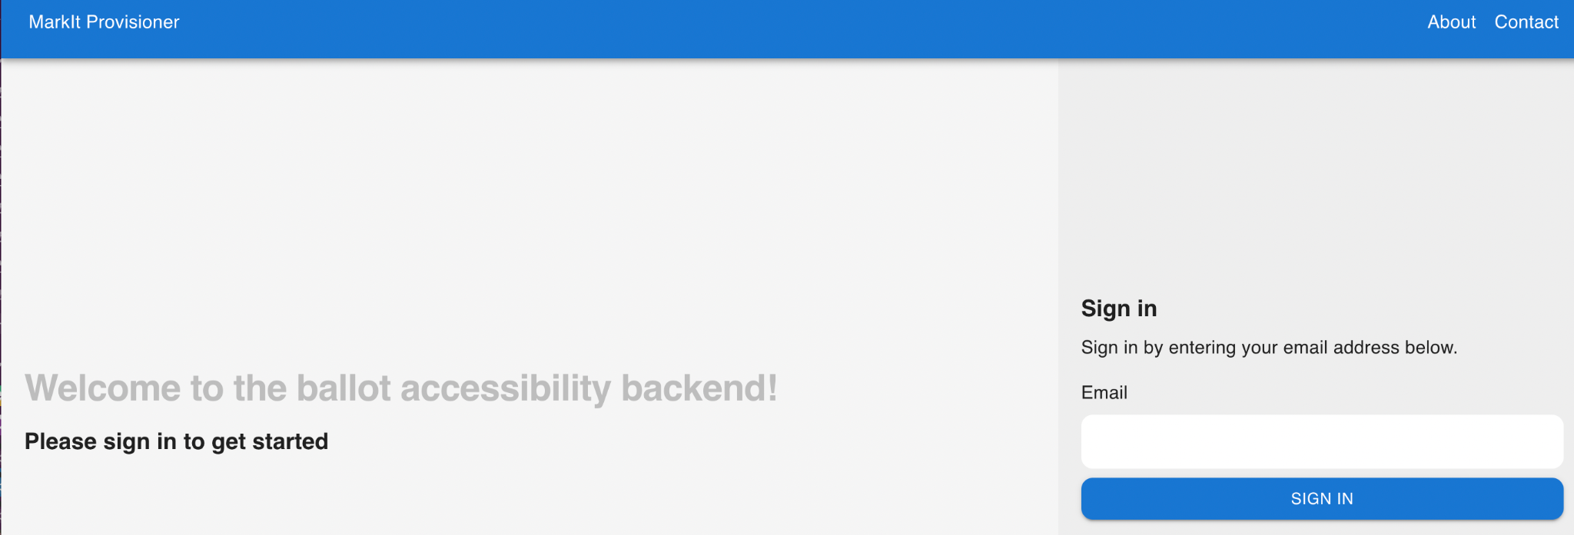

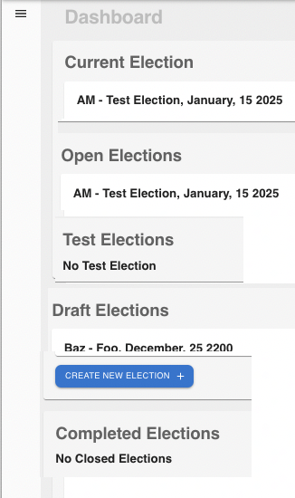

**Dashboard Overview:**

**Current Election:** This section will list the most recently edited election.

**Open Elections:** The section lists all the Open Elections. The mobile app is set up to display one Open Election.

**Test Elections:** This section lists all the elections being tested. At this time, the mobile app is not set up to display any test elections.

**Draft Elections:** This section lists all elections that are set up and not yet in test mode.

**Complete Elections**: This section lists all elections that have been closed.

**To Create a New Election:**

Option 1: Select “CREATE ELECTION” from the menu in the upper left corner

Option 2: Click on the blue “CREATE NEW ELECTION” button on the Dashboard

Then enter information into the general information page.

**Date Data Entry**: Enter digits only and use leading zeros.

For example, for April 1, 2023 enter 04012023

**General Information Page**

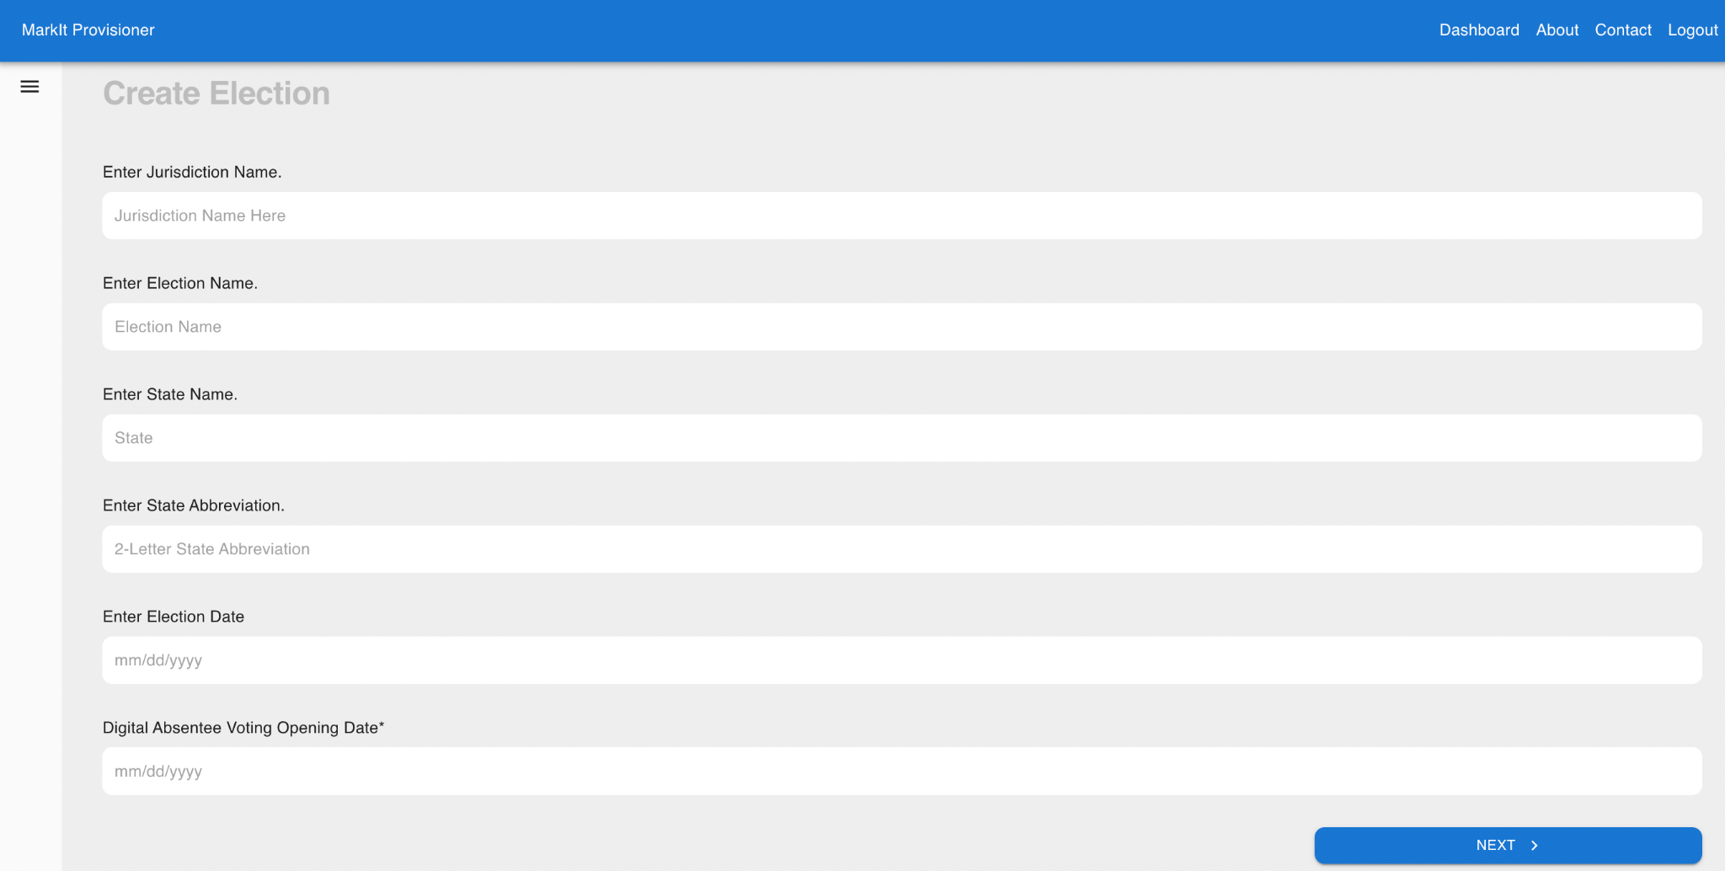

**Election Options Page**

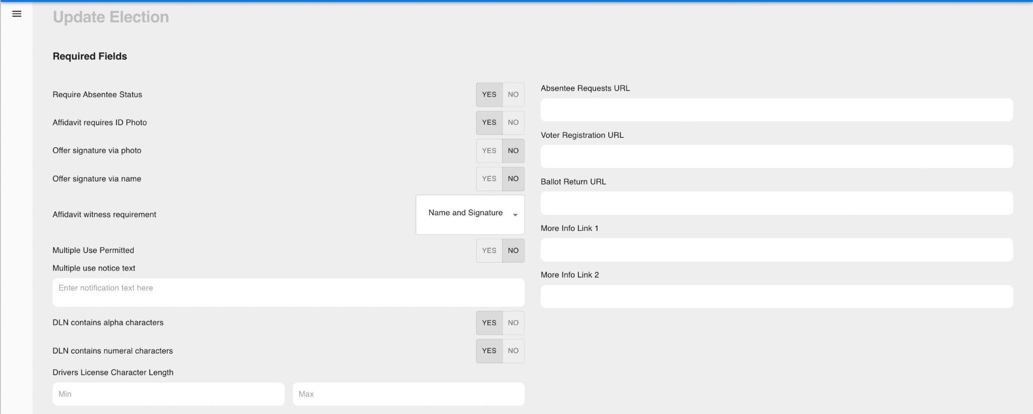

For early testing to best match test voter data, these are the preferred election options:

Require Absentee Status: No

Affidavit requires ID Photo: Yes

Offer signature via photo: No

Affidavit witness requirement: Name and Signature

Multiple Use Permitted: Yes

DLN contains alpha characters: Yes

DLN contains numeral characters: Yes

Drivers License Character Length: min 6 and max 6

You may enter anything into the Multiple use notice text and URL fields. The data will be provided to the app and displayed.

**Data Upload Pages**

There are three artifacts to upload as part of creating an election: Election Definition File (EDF), the set of Ballot Files, and a Voter File to use both for the test voter file and the production, with or without modification to the voter records.

Sample files have been uploaded into a shared folder [here](https://drive.google.com/drive/folders/1__ReGqNiIqY0GDkCHWHiRMi_z8CcYxo-?usp=share_link). These files are in ZIP form, because at this time, each of these files must be uploaded as a ZIP file. Download these sample files to your computer and then upload them.

As shown in the screenshot below, the first step is to “Upload Election Definition File”. At this time, it is required to wait until that upload is complete, before proceeding to the next step:

“Upload Ballot Files.”

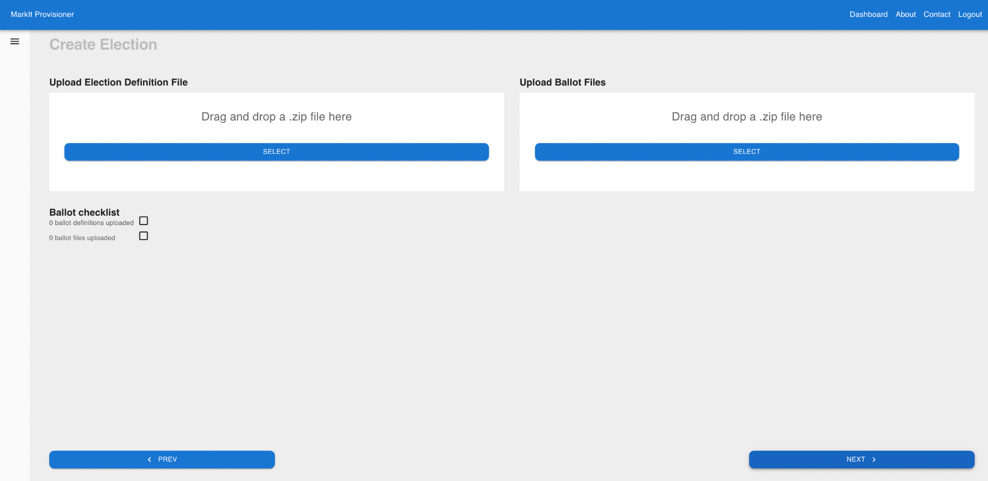

The next step is to upload the test voter file. You can use the voter file provided as a text fixture, as is, or you may modify the test voters’ names. Note, if you would like to edit the voter file, please save your changes as a .csv file and compress it to create a ZIP file. At this time, uploads are limited to ZIP files.

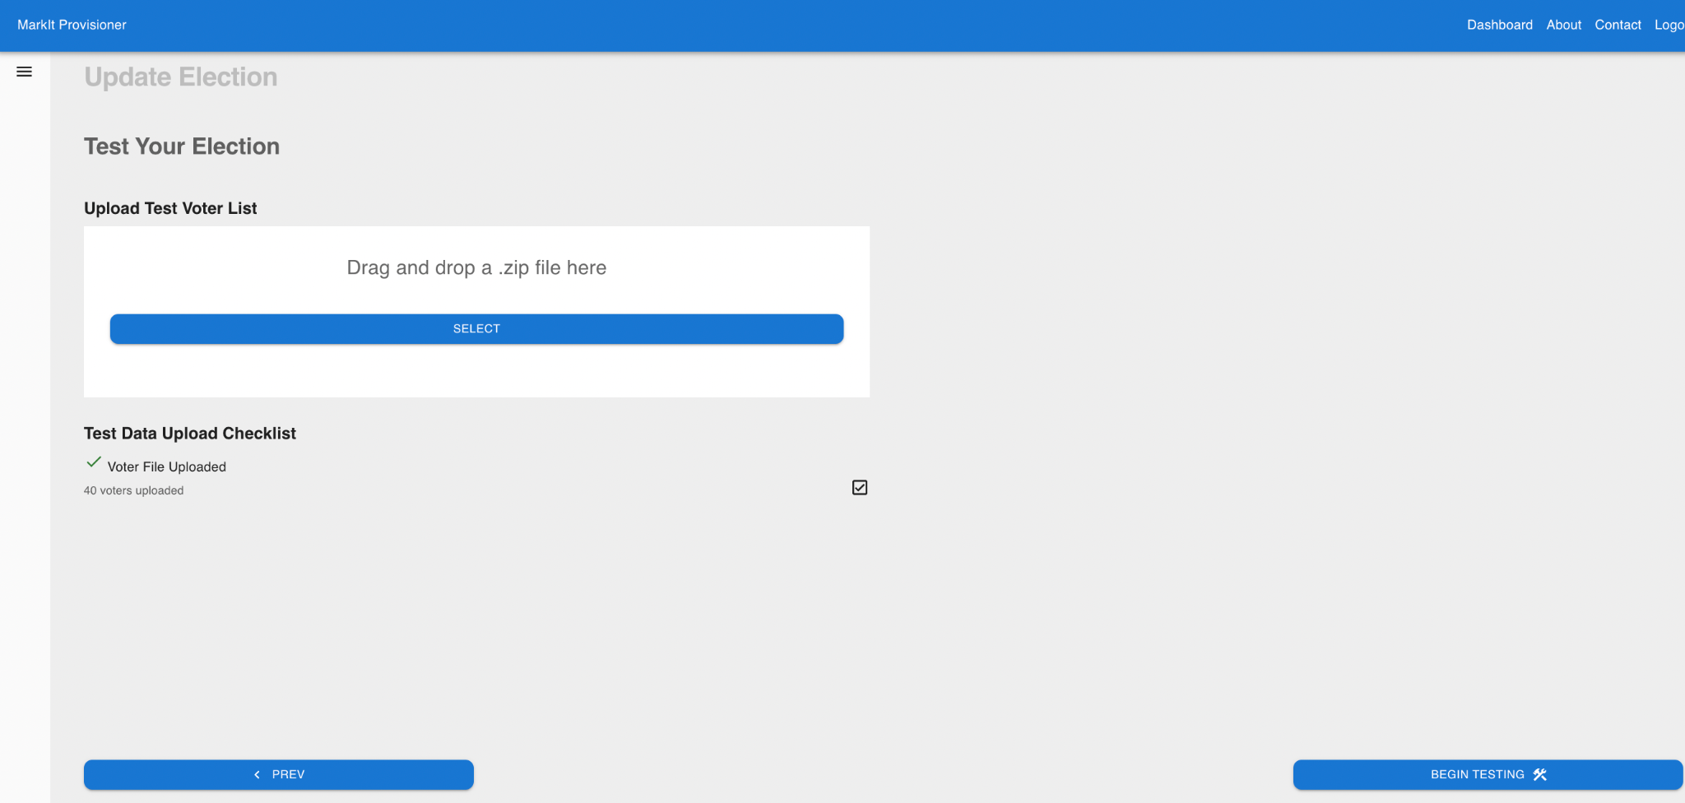

Once all data has been successfully uploaded, select the “BEGIN TESTING” button and confirm this choice.

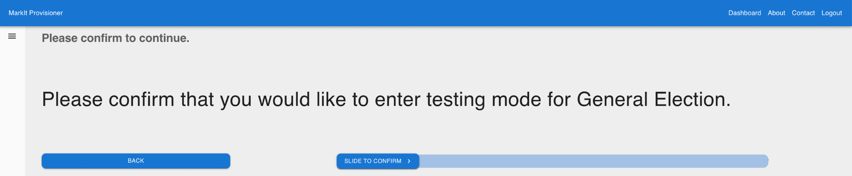

From this point, there are few more Provisioner steps, starting with exiting test mode; this test procedure does not include the use of test clients for LAT activity. The final two steps:

* Upload the production voter file.
* Open the election for clients.

This newly created and active election will now appear on the Dashboard under Current Election and Test Elections.

At this time, the mobile device is set up for Open Elections.

The next section of this guide shows the UI procedure for these final steps.

**Closing Testing and Completing Setup for an Open Election**

Click on the “VIEW TESTING STATUS” button, then the “I’M DONE TESTING” button and confirm.

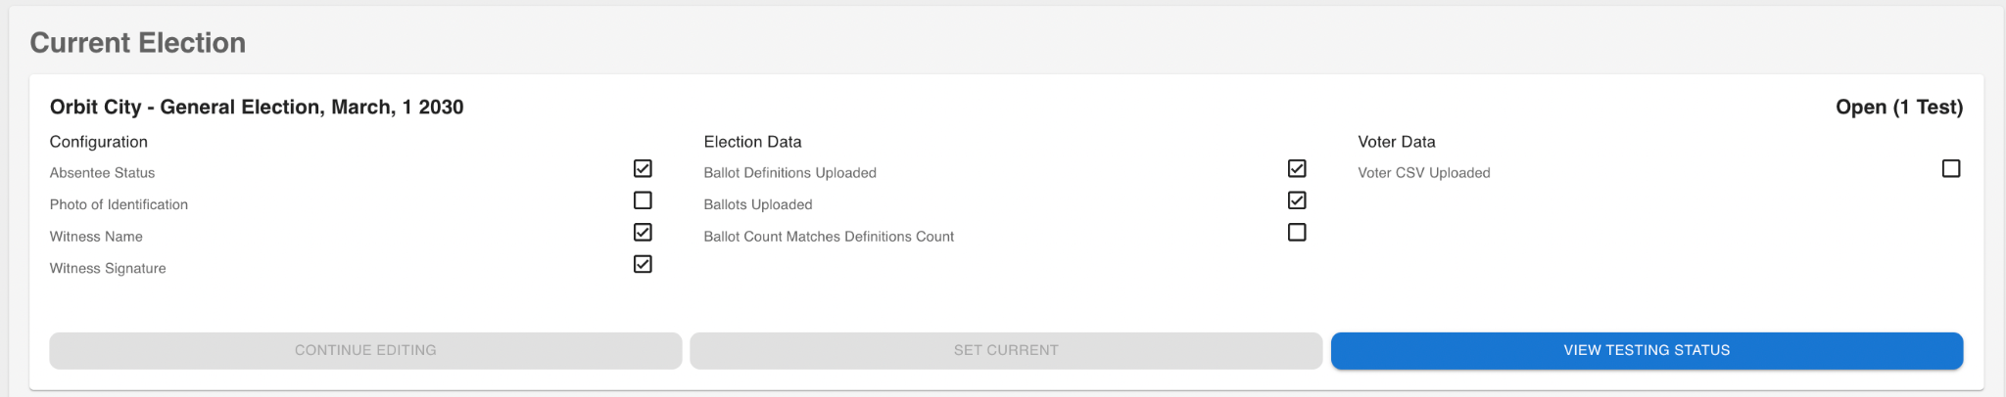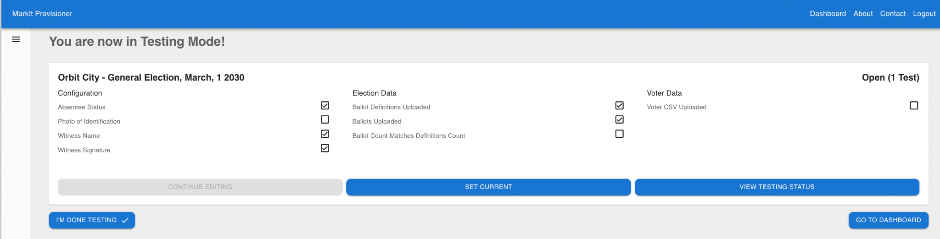

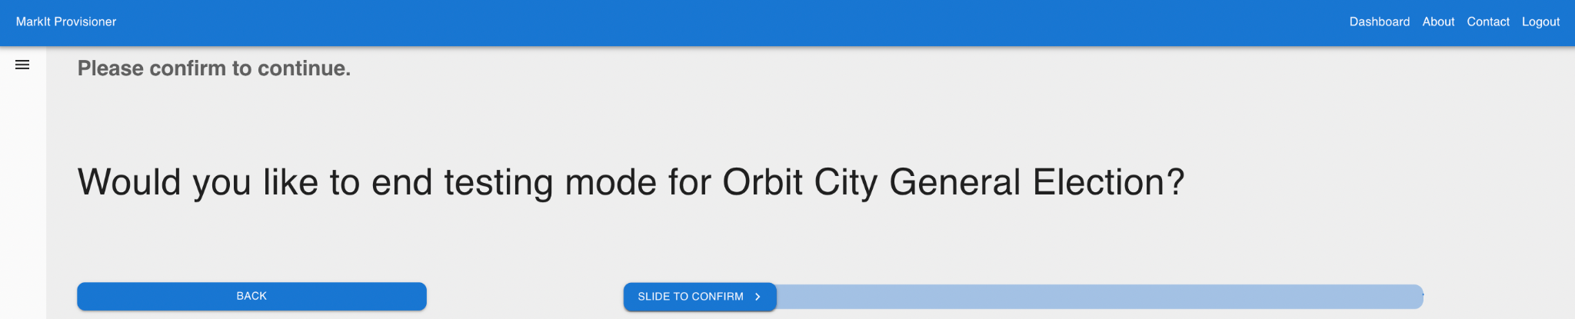

This election now appears in the Current Election and Draft Elections sections of the Dashboard. Click on the “CONTINUE EDITING” button to confirm your setting and upload your production voter file.

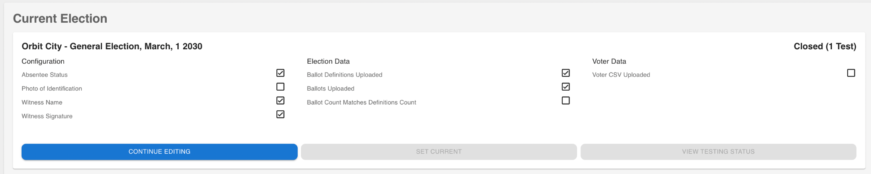

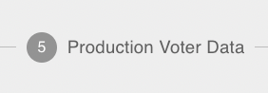

In order to continue and upload your production voter file, click on Step 5 at the bottom of this election detail to get to the correct page.

Upload the zipped voter file and select the “Next” button to continue.

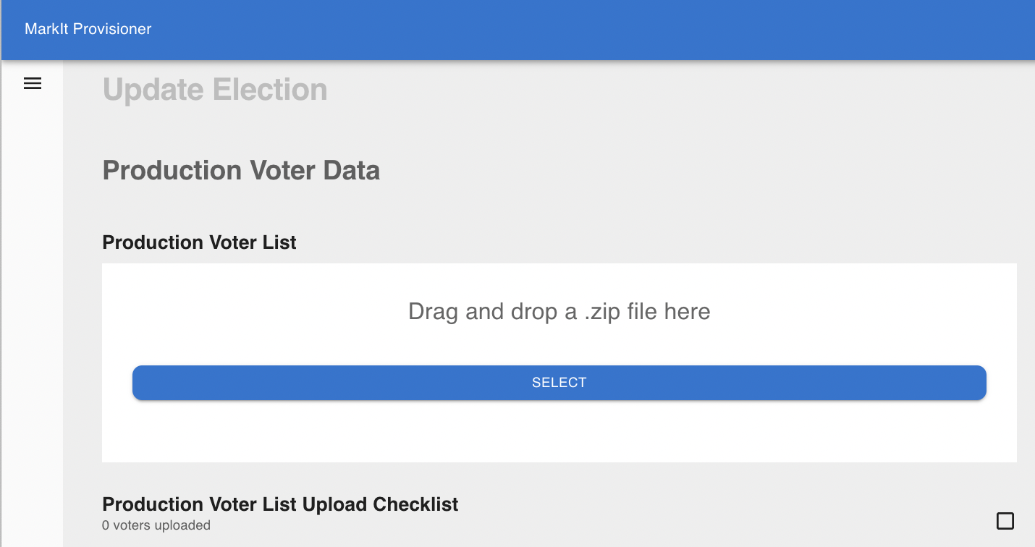

Select the “Open Election” button.

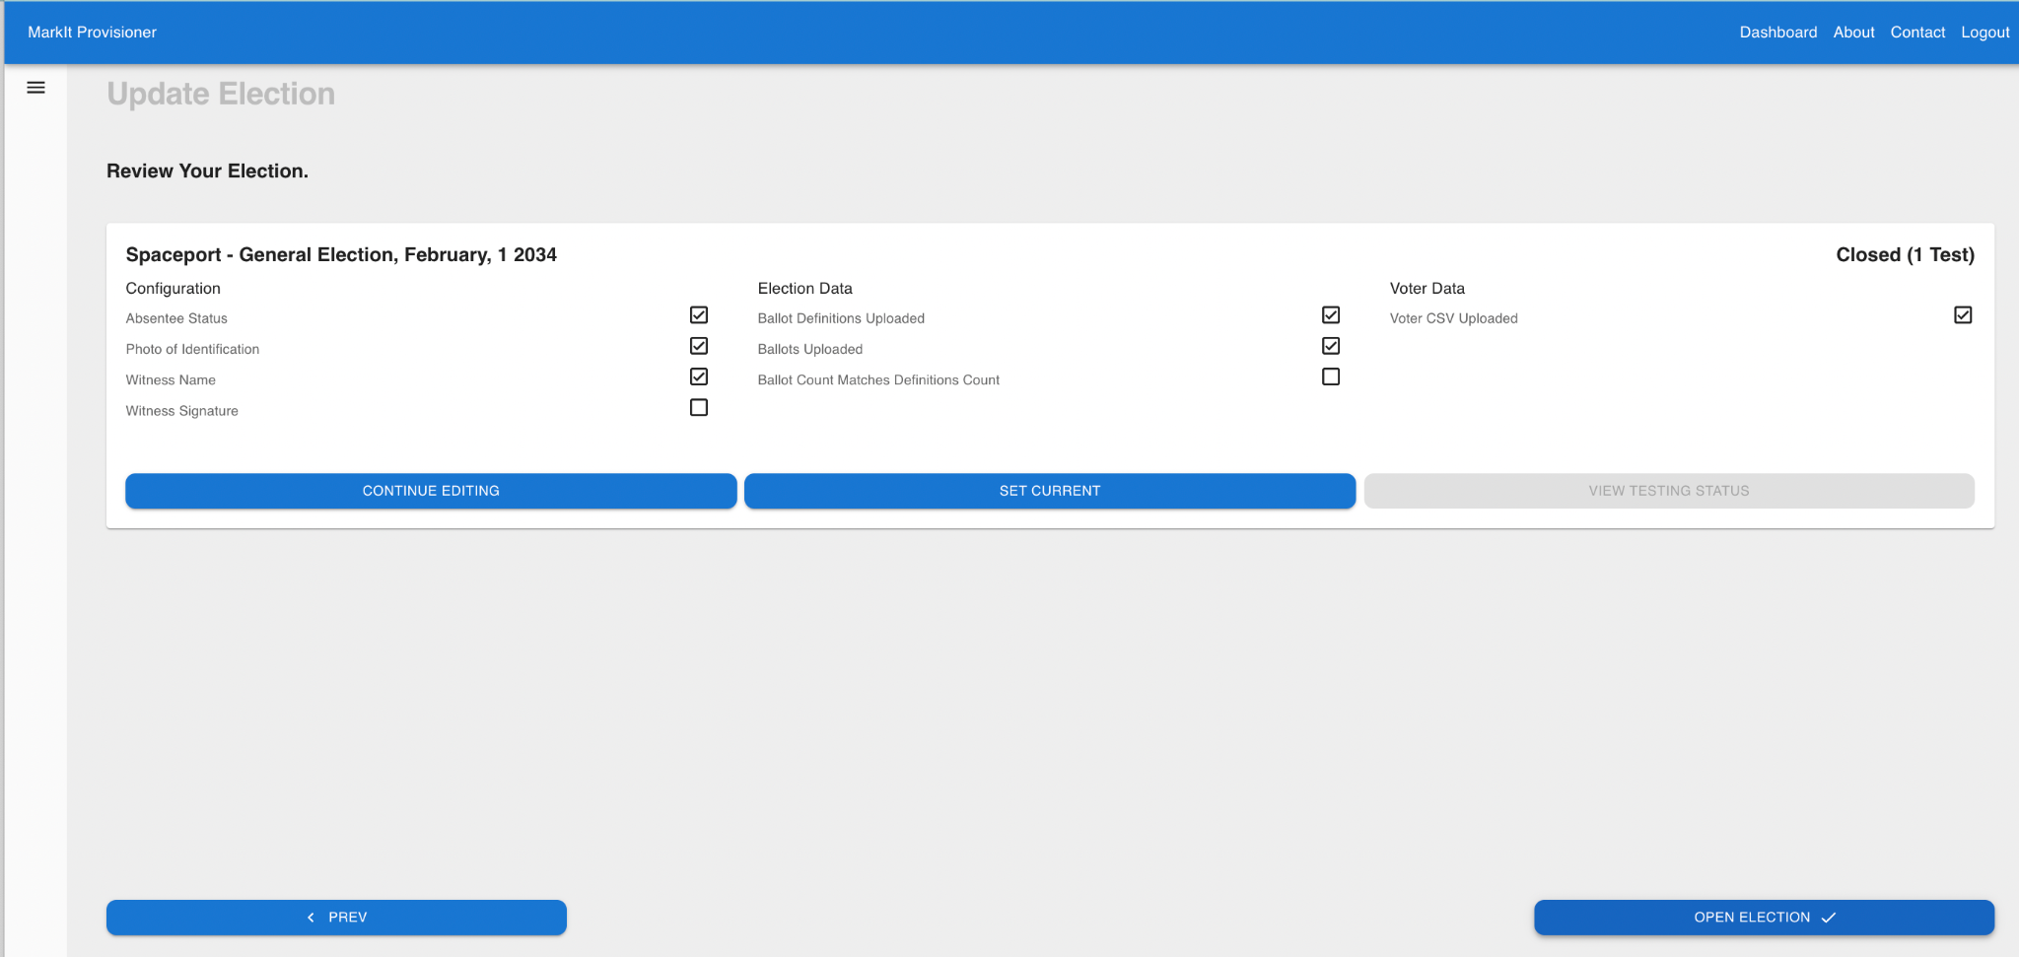

And Confirm your selection.

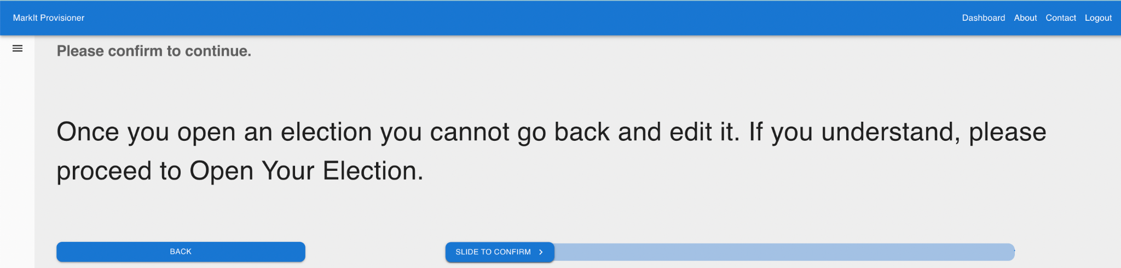

On the Dashboard, this election is now displayed under Current Election and Open Election sections.

Note: If more than one election is being worked on, the single active election will be the one in the Current Election section. This is the election Provisioner serves data to the apps.

**Demonstrating App Usage of Provisioner**

Using the demo version of the MarkIt app, do a voter session using one of the voters listed in the [production voter file](https://docs.google.com/spreadsheets/u/0/d/1u5Ps7nWaYHTMMxxWkVND491bTePSUUjbEirI2oZL80c/edit). The app will accept voter info, and do a voter lookup with the Provisioner. After completing voter lookup, the app will retrieve from the Provisioner the data needed for ballot marking and affidavit preparation. Also provisioned are the text and URLs from the configuration step (see page 3, Election Options), which the app will display if the user session includes an error conditions that refer to an external web page.

After completing the ballot marking process and providing additional information for the affidavit -- based on data provided by the Provisioner -- there is no further Provisioner related real time activity to demonstrate in the app.